**About The Project**

This project contains a Bank registration Portal.

The customers can quickly apply for the respective loans as well as Opening an Account.

It requires minimum amount of information (only necessary bit letting Bank have an idea about the customer) stored and assuring the customers of soon contact.

If the program shows any type of error regarding database either change the name of my database or install sqlite.

The first screen is a splash screen containing information about me.

Then after 8 seconds, the screen disappears and then a new window appears. This window is an introductory window telling about all of the services provided by the Bank.

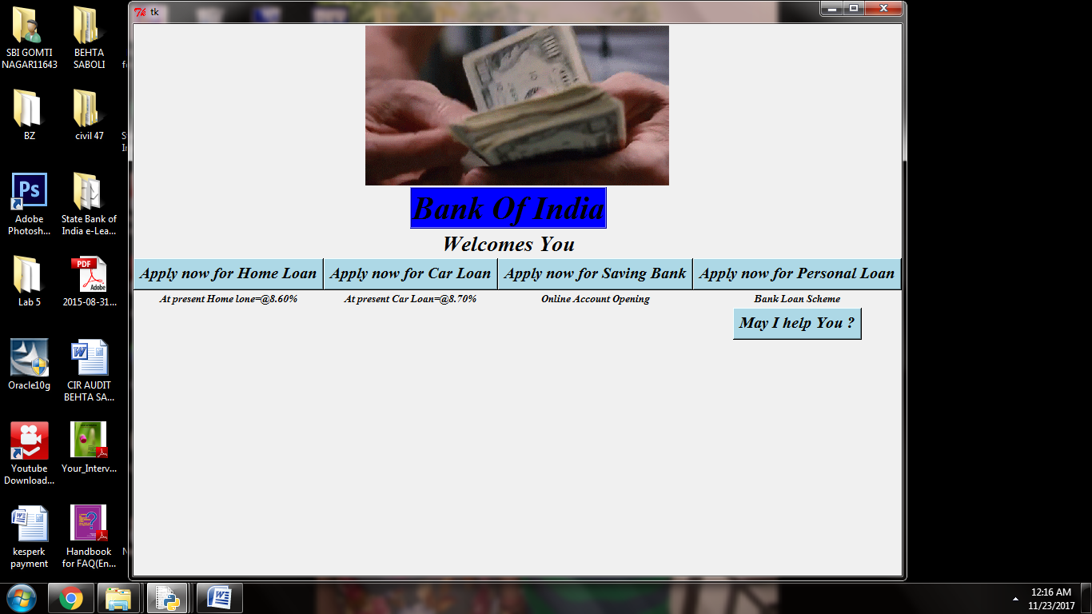

There are five functions shown.

Four of them are-Home Loan, Personal Loan, Car Loan, Account Opening .

Each one have its own window for customer registration.

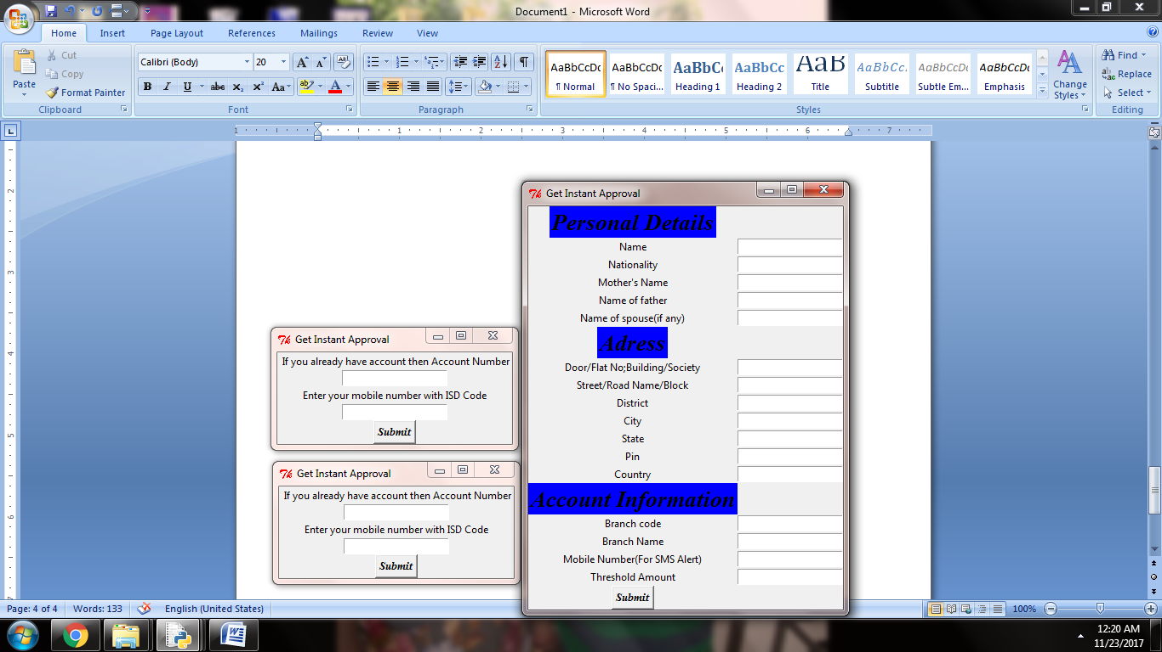 When one presses submit, there a message box appears showing the message of “We will contact you soon” .

Fifth one is complain or query section where the customer can either ask a query or report his complain.

On Clicking ‘May I help you’, a text box appears working as a page for text. It is somewhat based on a rough text-Editor. On clicking on submit another message box appear of confirmation of receiving complain.

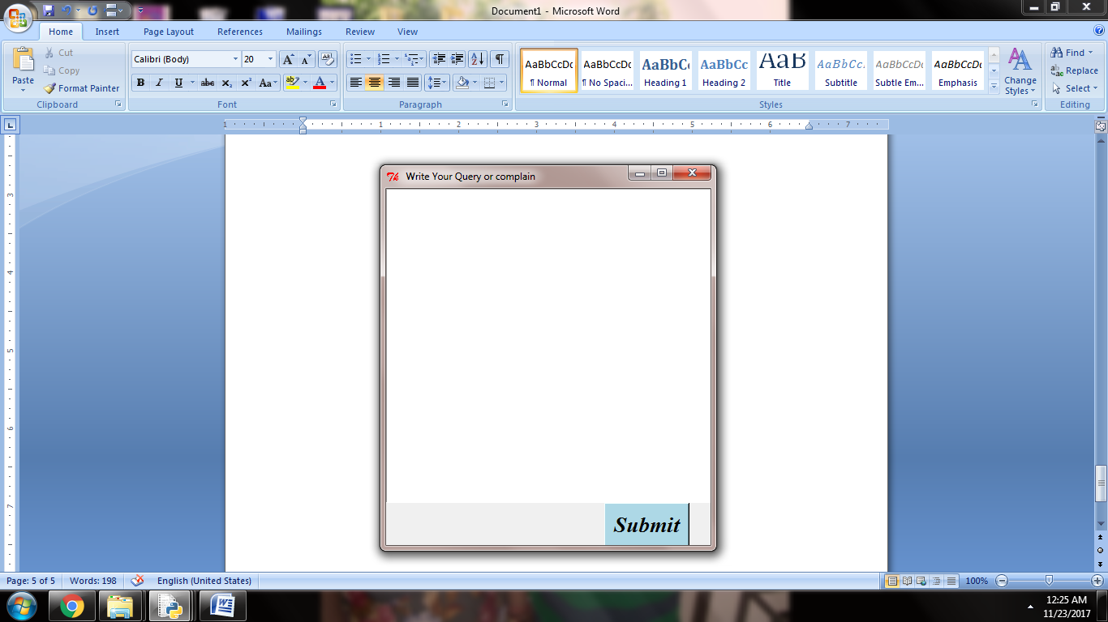

Thank You